Creating a Private Amazon S3 Bucket
Objective: To create a secure, private Amazon S3 bucket that restricts all public access, enforces encryption at rest, and ensures only authorized users can read or write objects .

Step1 - Sign in to AWS Console
- Go to https://aws.amazon.com and sign in to your AWS Management Console.
- Click on the S3 service .From the S3 dashboard click on “Create Bucket”.
- 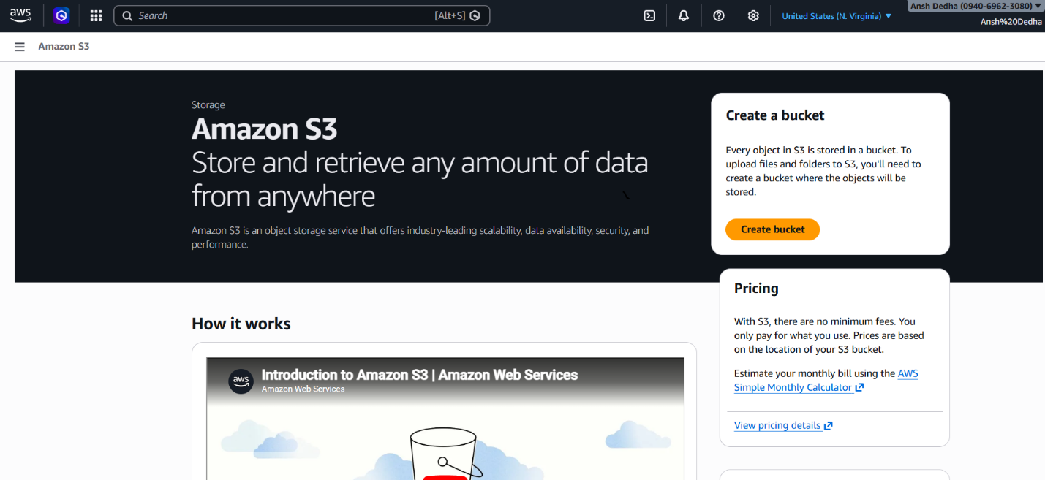

Step2 - Configure Bucket Name
- On the S3 dashboard, click on "Create Bucket". Enter a unique Bucket Name (must be globally unique).
- 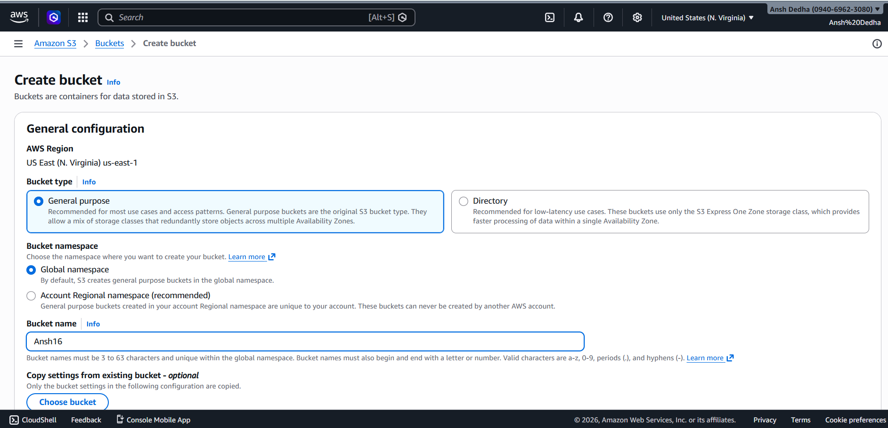

Step-3 Block All Public Access & Disable ACLs
- Under the Object Ownership section, select "Bucket owner enforced". This disables ACLs (Access Control Lists) for the bucket and all objects inside it.
Scroll down to the Block Public Access settings and ensure public access is blocked.
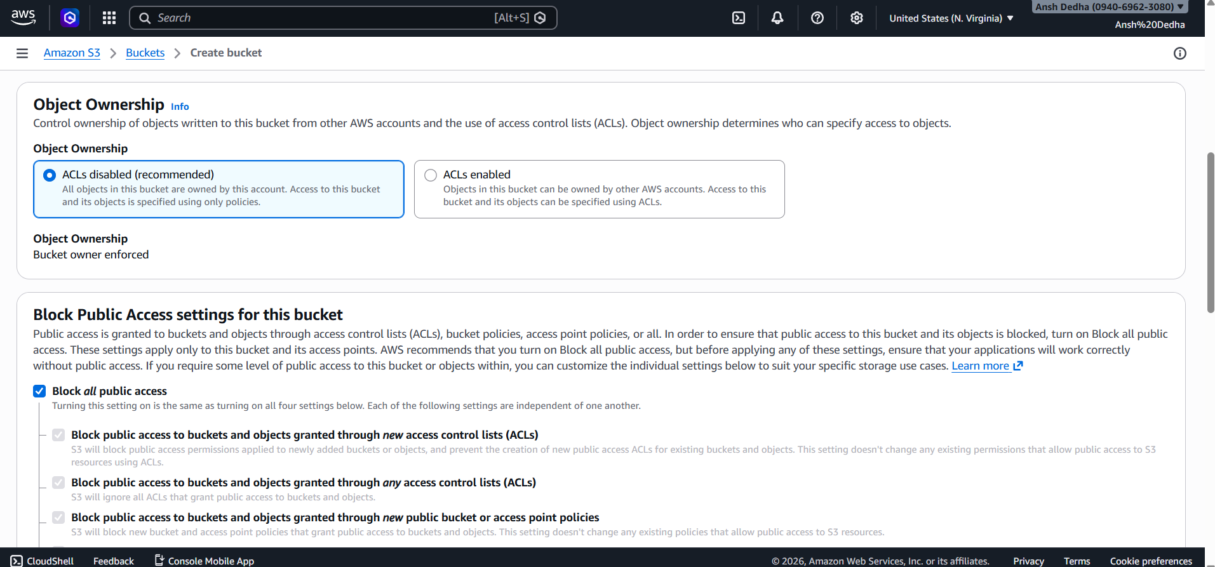

- Step 4 — Leave Other Settings as Default than scrool down and click on “Create Bucket”.
- 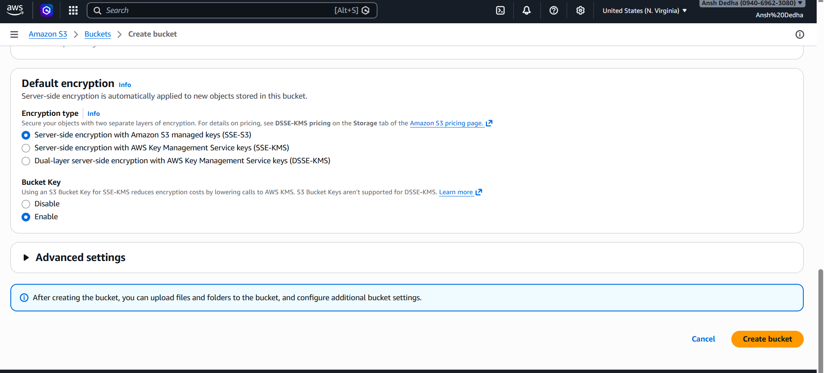

Step-5 Add an Object to the Bucket.
- Click on “Upload”. Click “Add Files” and select the file you want from your device. Leave permission as default(private).
- Click “Upload” to add the object to the bucket
- 
 